**NetSim Auto Test GUI**

**Requirements:** Python 3.11 and later

**Project Download Link:**

**Auto Test**

The Auto Test program is designed to automate the execution of network scenarios without requiring any user input. It allows users to run simulations using the command line and obtain the corresponding results, including appMetrics.txt, Compare.txt, and results.txt files.

Fig : NetSim Auto Test GUI

The AutoTest-GUI.exe program accepts three parameters as input:

**Workspace bin Path:** This is the path where the NetSimcore.exe (the network simulation software) is located.

**Configuration.netsim file or Experiments folder path:** You can either specify the path to a specific configuration.netsim file or the path to the folder containing multiple experiments.

**License file or Server IP address:** If you are using a dongle-based floating license, enter the Server IP address. If you are using a cloud-based license, enter the license file path.

**Steps to perform using the Auto Test program:**

1. Download the python utility using Download Link and Extract the Zip Folder
2. Once the folder is extracted, navigate to the folder where the Python utility is located.
3. Run AutoTest-GUI.exe will launch a GUI as shown in Fig 1
4. Click the "Browse" button to select the workspace bin folder where NetSimcore.exe is located.
5. Browse and select either a specific configuration.netsim file or the path to the experiments folder.

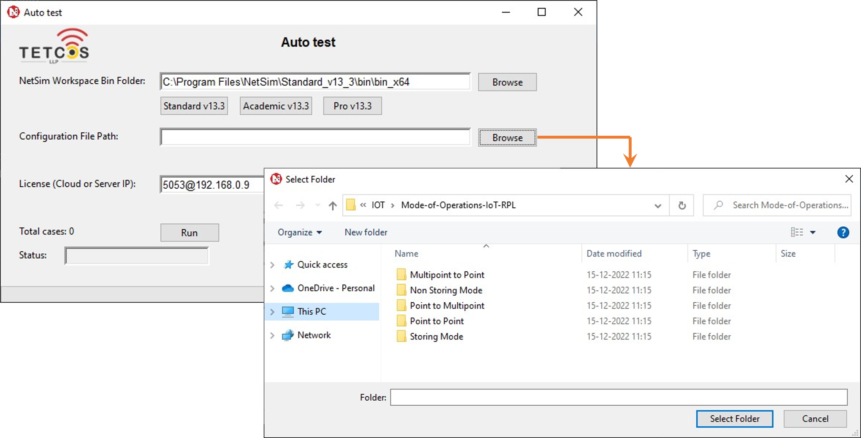

Fig : Browse the path of Experiments Folder

1. Enter the Server IP address if the license is a dongle based floating license, enter the license file path if it is a cloud based.
2. Click the "Run" button to start simulating the experiment scenarios.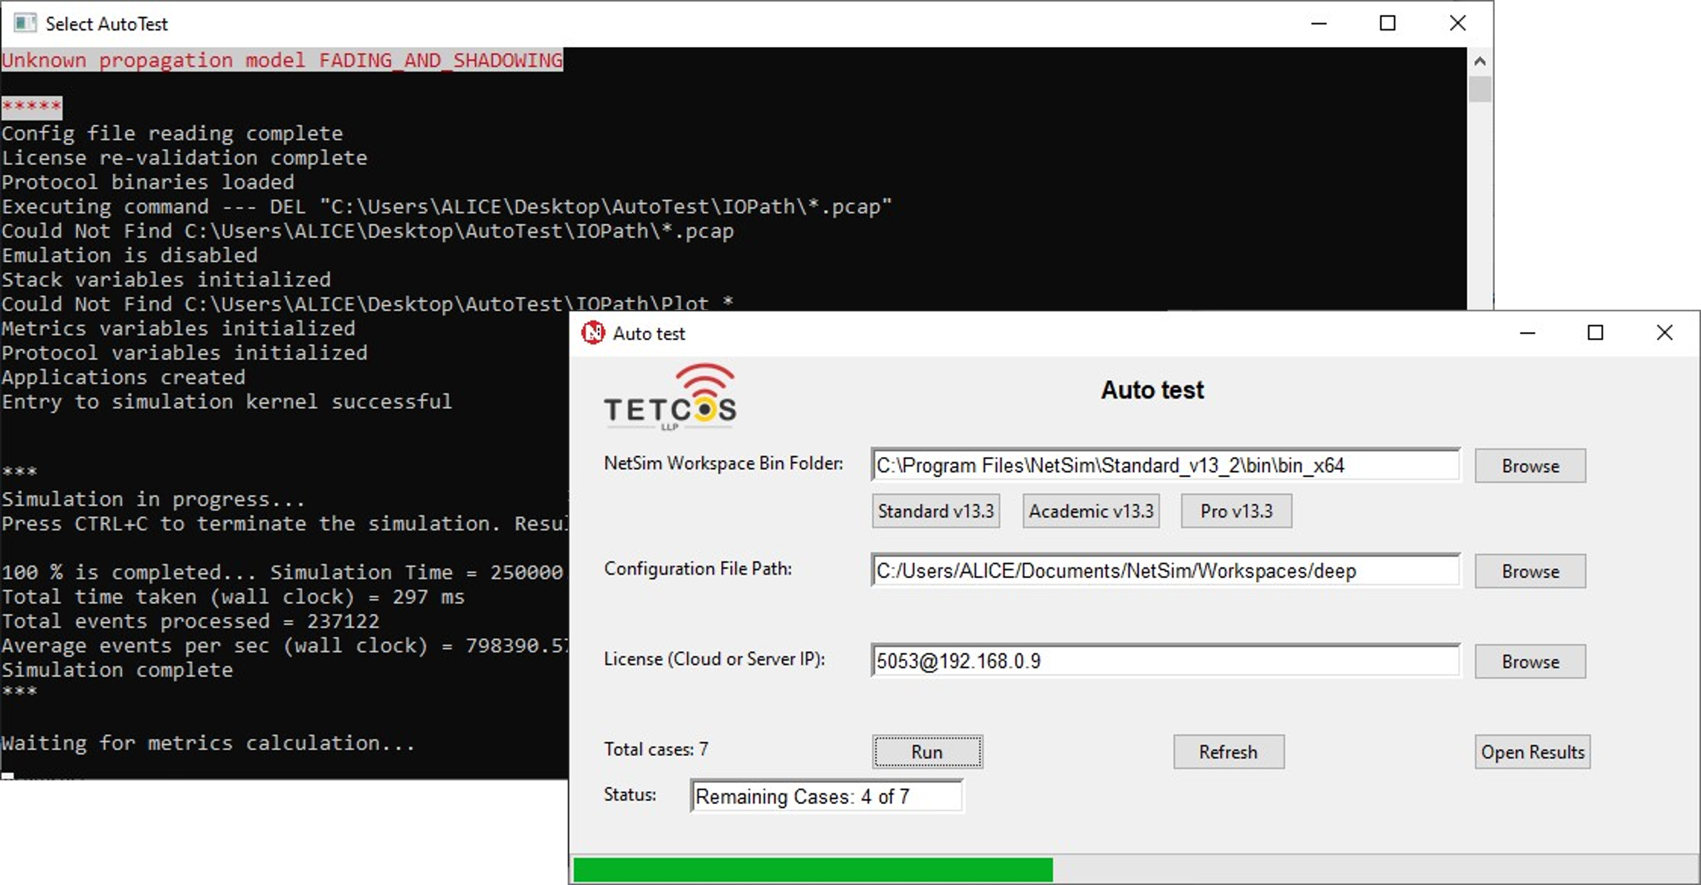

Fig : Simulation Progress during Auto Test

1. Use the "Refresh" button to clear the entry fields if needed.
2. After the simulations are completed, click the "Open Results" button to view the results.txt file.

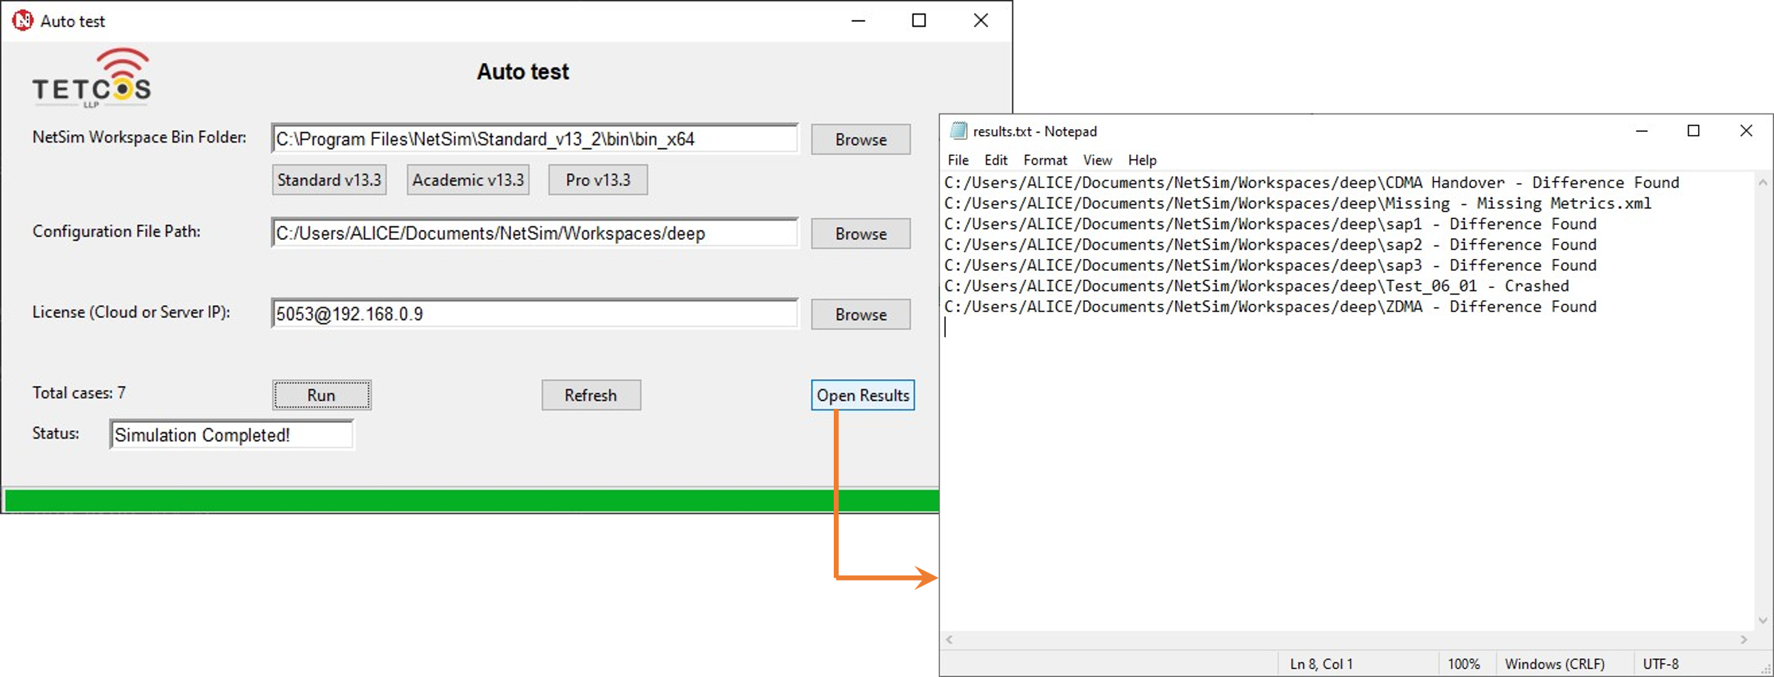

Fig : Opening results file created by Auto Test

The **results.txt** file displays information about the success or crash of each simulation, plot differences, and any differences found.

The **Compare.txt** file indicates if there are any differences in the metrics.xml file between the workspace and the simulation results.

The **appMetrics.txt** file contains application metrics such as throughput and delay for each scenario.

This Auto Test program simplifies the process of running network simulations and automates the analysis of simulation results.